CHAPTER 3: HOW SECURITIES ARE TRADED

PROBLEM SETS

- Stop-loss order: allows a stock to be sold if the price falls below a predetermined level. Stop-loss orders often accompany short sales. Limit sell order: sells stock when the price rises above a predetermined level. Market order: either a buy or sell order that is executed immediately at the current market price

2. In response to the potential negative reaction to large [block] trades, trades will be split up into many small trades, effectively hiding the total number of shares bought or sold.

3. The use of leverage necessarily magnifies returns to investors. Leveraging borrowed money allows for greater return on investment if the stock price increases. However, if the stock price declines, the investor must repay the loan, regardless of how far the stock price drops, and incur a negative rate of return. For example, if an investor buys an asset at $100 and the price rises to $110, the investor earns 10%. If an investor takes out a $40 loan at 5% and buys the same stock, the return will be 13.3%, computed as follows: $10 capital gain minus $2 interest expense divided by the $60 original investment. Of course, if the stock price falls below $100, the negative return will be greater for the leveraged account.

4. (a) A market order is an order to execute the trade immediately at the best possible price. The emphasis in a market order is the speed of execution (the reduction of execution uncertainty). The disadvantage of a market order is that the price at which it will be executed is not known ahead of time; it thus has price uncertainty.

5. (a) A broker market consists of intermediaries who have the discretion to trade for their clients. A large block trade in an illiquid security would most likely trade in this market as the brokers would have the best access to clients interested in this type of security.

The advantage of an electronic communication network (ECN) is that it can execute large block orders without affecting the public quote. Since this security is illiquid, large block orders are less likely to occur and thus it would not likely trade through an ECN.

Electronic limit-order markets (ELOM) transact securities with high trading volume. This illiquid security is unlikely to be traded on an ELOM.

6. a. The stock is purchased for: 300 × $40 = $12,000
The amount borrowed is $4,000. Therefore, the investor put up equity, or margin, of $8,000.

- If the share price falls to $30, then the value of the stock falls to $9,000. By the end of the year, the amount of the loan owed to the broker grows to:
$4,000 × 1.08 = $4,320
Therefore, the remaining margin in the investor’s account is:
$9,000 − $4,320 = $4,680
The percentage margin is now: $4,680/$9,000 = 0.52, or 52%
Therefore, the investor will not receive a margin call.

- The rate of return on the investment over the year is:
(Ending equity in the account − Initial equity)/Initial equity
= ($4,680 − $8,000)/$8,000 = −0.415, or −41.5%

Alternatively, divide the initial equity investments into the change in value plus the interest payment:
($3,000 loss + $320 interest)/$8,000 = -0.415.

7. a. The initial margin was: 0.50 × 1,000 × $40 = $20,000
As a result of the increase in the stock price Old Economy Traders loses:
$10 × 1,000 = $10,000
Therefore, margin decreases by $10,000. Moreover, Old Economy Traders must pay the dividend of $2 per share to the lender of the shares, so that the margin in the account decreases by an additional $2,000. Therefore, the remaining margin is:
$20,000 – $10,000 – $2,000 = $8,000

b. The percentage margin is: $8,000/$50,000 = 0.16, or 16%
So there will be a margin call.

c. The equity in the account decreased from $20,000 to $8,000 in one year, for a rate of return of: (−$12,000/$20,000) = −0.60, or −60%

8. a. The buy order will be filled at the best limit-sell order price: $50.25

b. The next market buy order will be filled at the next-best limit-sell order price: $51.50

c. You would want to increase your inventory. There is considerable buying demand at prices just below $50, indicating that downside risk is limited. In contrast, limit sell orders are sparse, indicating that a moderate buy order could result in a substantial price increase.

9. a. You buy 200 shares of Telecom for $10,000. These shares increase in value by 10%, or $1,000. You pay interest of: 0.08 × $5,000 = $400
The rate of return will be: 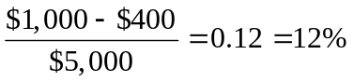

b. The value of the 200 shares is 200P. Equity is (200P – $5,000). You will receive a margin call when:
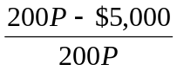= 0.30 ⇒ when P= $35.71 or lower

10. a. Initial margin is 50% of $5,000, or $2,500.

b. Total assets are $7,500 ($5,000 from the sale of the stock and $2,500 put up for margin). Liabilities are 100P. Therefore, equity is ($7,500 – 100P). A margin call will be issued when:
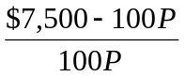= 0.30 ⇒ when P = $57.69 or higher

11. The total cost of the purchase is: $20 × 1,000 = $20,000
You borrow $5,000 from your broker and invest $15,000 of your own funds. Your margin account starts out with equity of $15,000.
a. (i) Equity increases to: ($22 × 1,000) – $5,000 = $17,000
Percentage gain = $2,000/$15,000 = 0.1333, or 13.33%
(ii) With price unchanged, equity is unchanged.
Percentage gain = zero
(iii) Equity falls to ($18 × 1,000) – $5,000 = $13,000
Percentage gain = (–$2,000/$15,000) = –0.1333, or –13.33%
The relationship between the percentage return and the percentage change in the price of the stock is given by:
% return = % change in price × 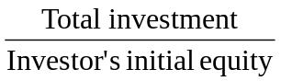= % change in price × 1.333
For example, when the stock price rises from $20 to $22, the percentage change in price is 10%, while the percentage gain for the investor is:
% return = 10% × 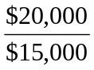= 13.33%

b. The value of the 1,000 shares is 1,000P. Equity is (1,000P – $5,000). You will receive a margin call when:
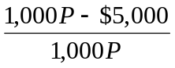= 0.25 ⇒ when P = $6.67 or lower

c. The value of the 1,000 shares is 1,000P. But now you have borrowed $10,000 instead of $5,000. Therefore, equity is (1,000P – $10,000). You will receive a margin call when:
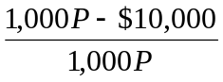= 0.25 ⇒ when P = $13.33 or lower
With less equity in the account, you are far more vulnerable to a margin call.

- By the end of the year, the amount of the loan owed to the broker grows to:
$5,000 × 1.08 = $5,400
The equity in your account is (1,000P – $5,400). Initial equity was $15,000. Therefore, your rate of return after one year is as follows:
(i) 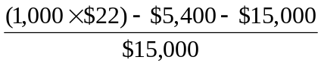= 0.1067, or 10.67%
(ii) 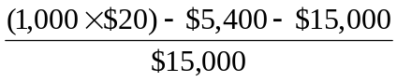= –0.0267, or –2.67%
- 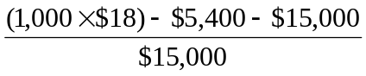= –0.1600, or –16.00%
The relationship between the percentage return and the percentage change in the price of Xtel is given by:
% return = 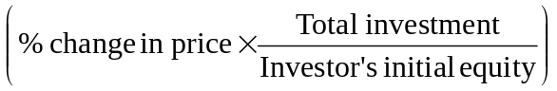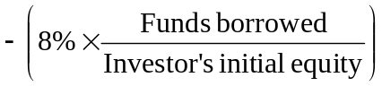
For example, when the stock price rises from $40 to $44, the percentage change in price is 10%, while the percentage gain for the investor is:
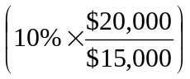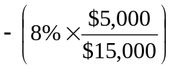=10.67%

e. The value of the 1000 shares is 1,000P. Equity is (1,000P – $5,400). You will receive a margin call when:
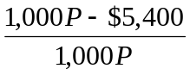= 0.25 ⇒ when P = $7.20 or lower

12. a. The gain or loss on the short position is: (–1,000 × ΔP)
Invested funds = $15,000
Therefore: rate of return = (–1,000 × ΔP)/15,000
The rate of return in each of the three scenarios is:
(i) Rate of return = (–1,000 × $2)/$15,000 = –0.1333, or–13.33%
(ii) Rate of return = (–1,000 × $0)/$15,000 = 0%
(iii) Rate of return = [–1,000 × (–$2)]/$15,000 = +0.1333, or+13.33%

b. Total assets in the margin account equal:
$20,000 (from the sale of the stock) + $15,000 (the initial margin) = $35,000
Liabilities are 500P. You will receive a margin call when:
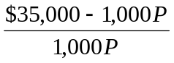= 0.25 ⇒ when P = $28 or higher

- With a $1 dividend, the short position must now pay on the borrowed shares: ($1/share × 1000 shares) = $1000. Rate of return is now:
[(–1,000 × ΔP) – 1,000]/15,000
(i) Rate of return = [(–1,000 × $2) – $1,000]/$15,000 = –0.2000, or –20.00%
(ii) Rate of return = [(–1,000 × $0) – $1,000]/$15,000 = –0.0667, or –6.67%
(iii) Rate of return = [(–1,000) × (–$2) – $1,000]/$15,000 = +0.067, or +6.67%
Total assets are $35,000, and liabilities are (1,000P + 1,000). A margin call will be issued when:
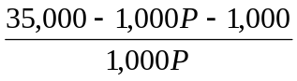= 0.25 ⇒ when P = $27.2 or higher

13. The broker is instructed to attempt to sell your Marriott stock as soon as the Marriott stock trades at a bid price of $70 or less. Here, the broker will attempt to execute but may not be able to sell at $70, since the bid price is now $69.95. The price at which you sell may be more or less than $70 because the stop-loss becomes a market order to sell at current market prices.

14. a. $55.50

b. $55.25

c. The trade will not be executed because the bid price is lower than the price specified in the limit-sell order.

d. The trade will not be executed because the asked price is greater than the price specified in the limit-buy order.

15. a. You will not receive a margin call. You borrowed $20,000 and with another $20,000 of your own equity you bought 1,000 shares of Ixnay at $40 per share. At $35 per share, the market value of the stock is $35,000, your equity is $15,000, and the percentage margin is: $15,000/$35,000 = 42.9%
Your percentage margin exceeds the required maintenance margin.

- You will receive a margin call when:
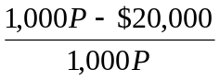= 0.35 ⇒ when P = $30.77 or lower

- The proceeds from the short sale (net of commission) were: ($21 × 100) – $50 = $2,050
A dividend payment of $200 was withdrawn from the account.
Covering the short sale at $15 per share costs (with commission): $1,500 + $50 = $1,550
Therefore, the value of your account is equal to the net profit on the transaction:
$2,050 – $200 – $1,550 = $300
Note that your profit ($300) equals (100 shares × profit per share of $3). Your net proceeds per share were:
$21 selling price of stock
–$15 repurchase price of stock
–$ 2 dividend per share
–$ 1 2 trades × $0.50 commission per share
$ 3

CFA PROBLEMS

1. a. In addition to the explicit fees of $70,000, FBN appears to have paid an implicit price in underpricing of the IPO. The underpricing is $3 per share, or a total of $300,000, implying total costs of $370,000.

b. No. The underwriters do not capture the part of the costs corresponding to the underpricing. The underpricing may be a rational marketing strategy. Without it, the underwriters would need to spend more resources in order to place the issue with the public. The underwriters would then need to charge higher explicit fees to the issuing firm. The issuing firm may be just as well off paying the implicit issuance cost represented by the underpricing.

2. (d) The broker will sell, at current market price, after the first transaction at $55 or less.

3. (d)

